Lobby display panels for GABRIEL, by Moira Buffini, Atlantic Theater Company production, 2010.

THE CHANNEL ISLANDS
The Channel Islands are comprised of the Islands of Guernsey, Jersey, Sark and Alderney and several other islets. They measure about 75 square miles, and lie between England and France. Guernsey, where Gabriel takes place, is a British Crown Dependency, but retains full autonomy over internal affairs. The United Kingdom represents the Islands internationally and is responsible for their defense. On June 15, 1940 however, The British government decided that due to the position of the Islands (closer to France than England) and the German occupation of the French coast, the Islands were indefensible, and therefore would be demilitarized and left to their own devices. Only fifteen days later, German forces took the Islands and occupied them until May 9, 1945. Of Guernsey’s 40,000 residents, 17,000 were evacuated, including school age children, unless their families chose to remain on the Island and keep their children there as well.

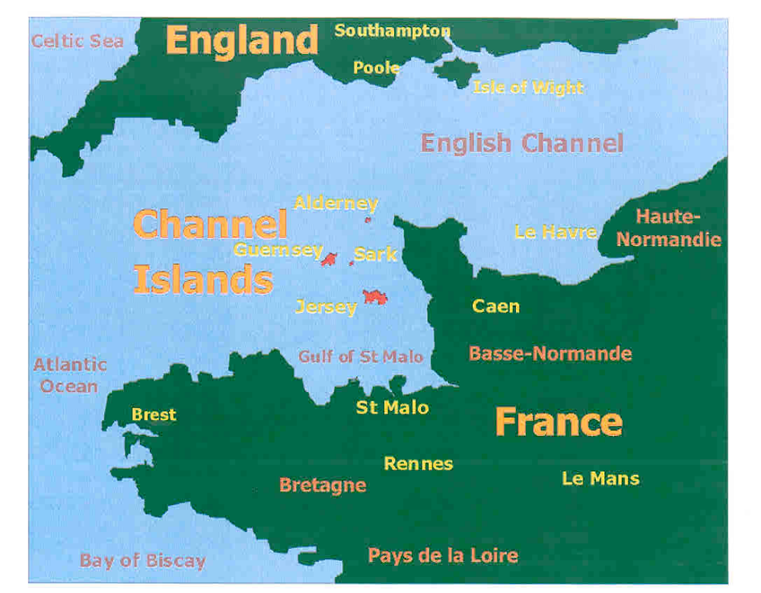

OCCUPATION
Approximately 25,000 German troops were stationed on the Islands, and they imported a labor force of approximately 7,000 from all over Europe, including Poland, Russia, Norway, France and Spain. These slave laborers were kept in concentration camps in Alderney and were forced to help German soldiers build concrete fortifications (as part of Hitler’s “Atlantic Wall” to ward off Allied attacks) and other structures including the famous German Military Underground Hospital and Ammunitions Store on Guernsey. This complex covered 75,000 square feet, its galleries were lined with 15,000 tons of concrete, and within its walls were an operating theatre, kitchen, cinema, staff quarters and wards for 500 patients. Approximately 700 of the slave laborers died during their captivity, and the remains of the structures they built can still be seen in Guernsey today.

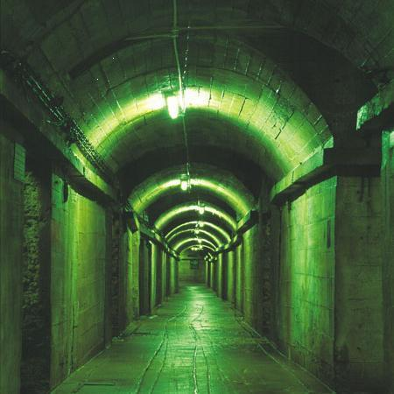

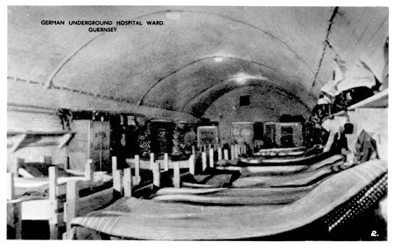

LIFE UNDER NAZI RULE
Life for Guernsey residents under occupation was severely restricted at best, utterly desperate at worst. The orders of the Commandant of the German Forces included: a curfew from 11pm-6am; prohibition of the sale or purchase of alcohol; and prohibition of the use of cars for private purposes. Listening to radios was also forbidden, as was insulting a German officer. The troops also attempted to “Germanize” the Island by printing German lessons in daily newspapers and showing only German films in movie houses. These constraints resulted in certain acts of resistance for the purpose of survival, such as selling alcohol on the black market, a practice from which Jeanne’s family profits in Gabriel. Fraternizing with German troops as Jeanne does, while not unusual, was frowned upon by Guernsey residents who referred to such women as “Jerry-bags.” For the few remaining Jewish residents (most had evacuated before June 1940) the constraints were even greater. Jews were required to register with the Inspector of Police, had their businesses closed or sold to Aryan administrators, were not allowed to change residence, were banned from places of public entertainment, and had restricted shopping hours of 3pm-4pm. Violation of these orders in some cases could be punishable by deportation to a concentration camp.
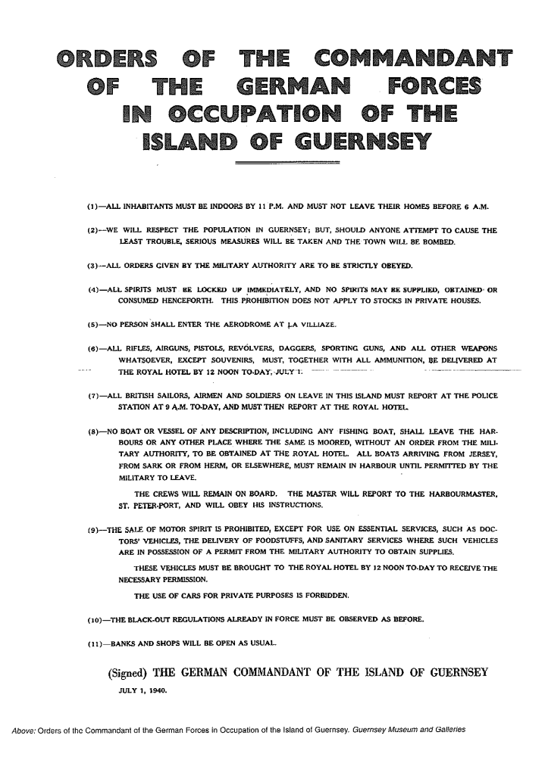

STARVATION AND LIBERATION
All residents of Guernsey suffered the effects of strict food rationing during the occupation. By 1943 people were reduced to bartering for food or much needed supplies. The Allied invasion of Normandy in June 1944 actually exacerbated the problem, cutting off German food and supplies that had been coming from France. Now German soldiers were starving along with Channel Islanders. Finally in December of 1944 the International Red Cross ship SS Vega brought life-saving goods to the Channel Islands. They made several more deliveries until the Islands were finally liberated on May 9, 1945.



